**DESIGN:**

**SCHEMAS**

**CUBE**

**DIMENSION AND FACT (MASTER AND TRANSACTION TABLES)**

**AND THE RELATIONSHIP BETWEEN THEM.**

**SCHEMAS:**

**HOW TABLES ARE ARRANGES OR ORGANIZED.**

1. **MASTER TABLE**
2. **TRANSACTION TABLE**

**HOW YOUR MASTER TABLES AND TRANSACTION TABLES ARE ARRANGED OR ORGANIZED.**

**MASTER TABLE IN DHW AND IN SSAS IS CALLED AS DIMENSION TABLE.**

**TRANSACTION TABLE IN DWH AND IN SSAS IS CALLED AS FACT TABLE.**

**99% OF MASTER TABLES ARE CALLED AS DIMENSIONS.**

**1% MASTER TABLE MAY ACT AS FACT.**

**99% OF TRANSACTION TABLES ARE CALLED AS FACTS.**

**1% TRANSACTION TABLE MAY ACT AS DIMENSION.**

**WHAT IS MASTER TABLE?**

1. **WHICH HAS MASTER DATA**
2. **INFORMATION ABOUT THE BUSINESS.**
3. **WHICH HAS PRIMARY KEY COLUMN**

**EX: BANK**

**A TABLE UNDER BANK DATABASE – CUSTOMER TABLE**

**IN CUSTOMER TABLE:**

1. **GIVES TEXTUAL INFORMATION ABOUT THE ENTITY.**
2. **PRIMARY KEY IS MUST.**
3. **CUSTOMER INFO SHOULD BE UNIQUE (SHOULD NOT BE REPEATED)**

**WHAT IS TRANSACTION TABLE?**

1. **WHICH HAS NUMERIC DATA.**
2. **DATA WHICH CAN BE CALCULATED.**
3. **DATA WHICH CAN BE MEASURED.**
4. **IN FACT TABLE, ALL KEYS ARE FK COLUMNS**

**IDENTIFY FACT AND DIMESNION TABLES IN OUR PROJECT.**

**FACT TABLE – FACTINTERNETSALES**

**DIMENSION TABLES – DIMPRODUCT, DIMCURRENCY, DIMTIME, DIMCUSTOMER….**

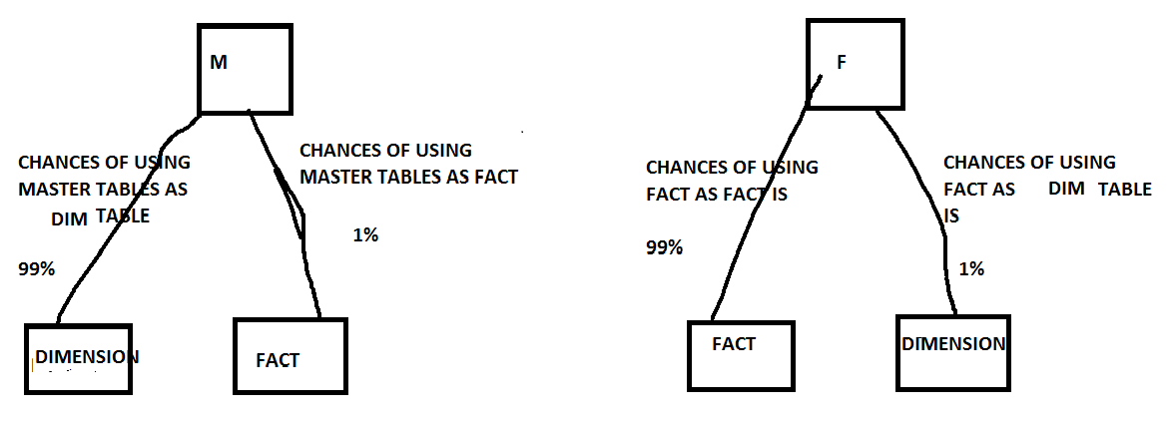

**DIMENSION SAYS IN WHICH ANGLE YOU WANT TO SEE THE BUSINESS INORDER TO ANALYSE .**

**FACTS SAYS WHAT METRICS YOU ARE GOING TO USE TO ANALYSE YOUR BUSINESS.**

**FACT – WHAT DATA YOU WANT TO SEE ? SALES, PROFITS, LOSS,…**

**DIMENSION – ALL THE SIDES.**

**HOW YOU WANT TO SEE THE DATA**

**THE WAY I WANT TO SEE**

**MONTH WISE**

**QUARTER WISE**

**SEMISTER OR HALF YEARLY WISE**

**YEARLY WISE**

**LOCATION WISE**

**PRODUCT WISE**

**BRAND WISE**

**CURRENCY WISE..**

**KEY POINTS : INDENTIFYING FAC T TABLES AND DIMENSION TABLES.**

**CLIENT WANTS TO SEE YEAR WISE SALES**

**SALES – IN WHICH TABLE -- FACTINTERNETSALES**

**YEAR (TIME) – IN WHICH TABLE – DIMDATE**

**SCHEMAS:**

**SCHEMA IS REPRESENTATION OF TABLES FOR CUBE DEVELOPMENT.**

**SIMPLY , IN DSV HOW ALL THE TABLES ARE LINKED IS CALLED SCHEMA.**

**THERE ARE BASICALLY TWO TYPES OF SCHEMAS:**

1. **STAR SCHEMA**
2. **SNOW-FLAKE SCHEMA**
3. **STAR SCHEMA:**

**WHERE FACT TABLE IS RELATED TO ALL DIMENSION TABLES DIRECTLY.**

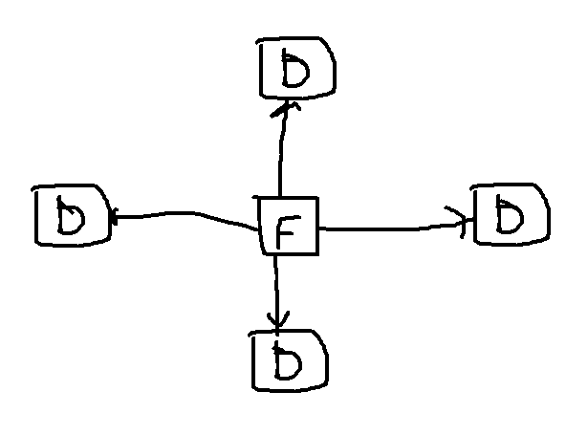

**WHEN FACT TABLE IS DIRECTLY RELATED WITH DIMENSION – STAR SCHEMA.**

1. **SNOW-FLAKE SCHEMA:**

**FACT TABLE IS NOT DIRECTLY RELATED TO ALL DIMENSIONS.**

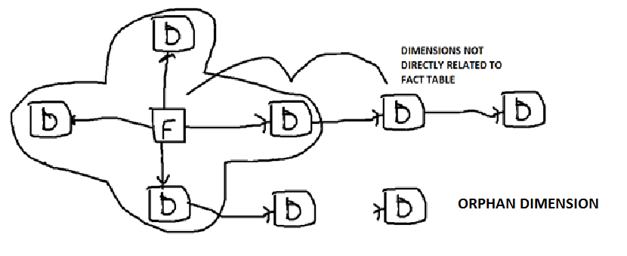

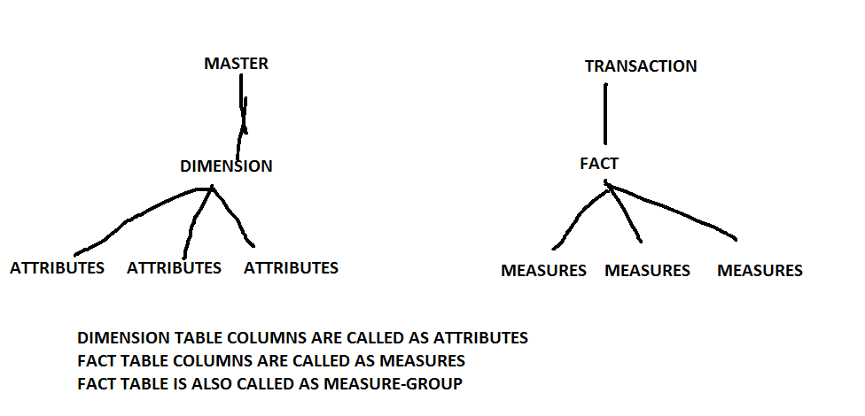

**WHAT IS CUBE?**

**COLLECTION OF DIMENSIONS (MASTER TABLE) AND FACT TABLES (TRANSACTION TABLE) RELATIONSHIP BETWEEN THEM**

**COLLECTION OF ATELAST ONE DIM AND ONE FACT AND R/S B/W THEM.**

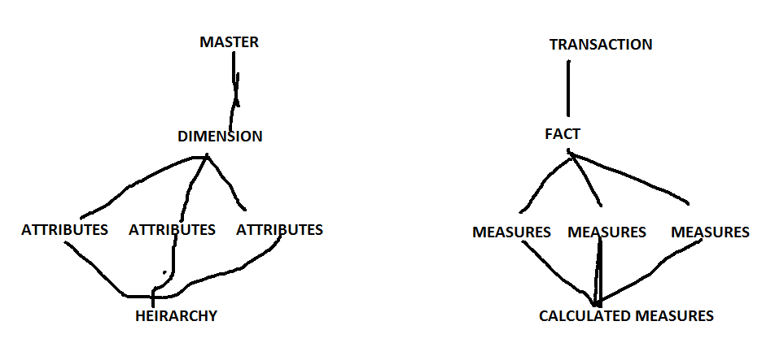

**ITS AN APPLICATION OR ENTITY WHICH HELPS THE END USER TO ANALYSE THE BUSINESS EASILY AS WELL QUICKLY TO TAKE BETTER DECISIONS.**

**LET US KNOW ABOUT BELOW CONCEPTS:**

1. **BUILD**
2. **DEPLOY**
3. **PROCESS**
4. **BUILD – USED TO CHECK ERRORS – SYNTAX ERRORS**
5. **DEPLOY : DEPLOY DEPLOYS OR COPIES THE SKELETION OR TEMPLATE OR STRUCTURE OF SSAS TO CUBE.**
6. **PROCESS: PROCESS WILL GET DATA FROM RELATIONAL DATBASE OR UNDERLYING DATABASE AND PUSHES DATA TO ANALYSIS SERVER OR CUBE DATABASE, CREATE THE INDEXES AT CUBE LEVEL AND CREATE AGGREGATIONS AT CUBE LEVEL.**

**RELATIONSHIPS:**

1. **NO RELATIONSHIP**
2. **REGULAR**
3. **FACT**
4. **REFERENCED**
5. **MANY TO MANY**
6. **DATA MINING – WHICH WE DON’T INCLUDE**

**FACT RELATIONSHIP – WHERE TABLE ACTING AS DIMENTION AS WELL FACT**

**MANY – MANY**

**STORAGEMODES**

**PARTITIONS**

**STORAGE MODES:**

**MOLAP – MULTIDIMENSIONAL OLAP**

**ROLAP - RELATIONAL OLAP**

**HOLAP – HYBRID OLAP**

**WHENEVER WE PROCESS THE CUBE:**

1. **IT READS AND LOADS THE DATA TO CUBE DATABASE.**
2. **IT CREATES AGGREGATIONS.**
3. **IT CREATES INDEXES.**
4. **MOLAP – MULTIDIMENSTINAL OLAP**
5. **ROLAP – RELATIONAL OLAP**
6. **HOLAP – HYBRID OLAP**

**PERFORMANCE:**

1. **PROCESSING PERFORMANCE**
2. **QUERYING PERFORMANCE.**

**MOVING CUBE FROM ONE SERVER TO OTHER SERVER:**

1. **BACKUP AND RESTORE**
2. **DIRECT DEPLOY**
3. **COPY SOLUTION AND DEPLOY**
4. **COPY ALL DB FILES AND DEPLOY**
5. **XMLA**
6. **SYNCHRONIZATION**